
NARROGIN Senior High School
English Assessment Cover Sheet – Upper School

STUDENT’S NAME |  | TEACHER’S NAME | JACKSON  DAVIDSON | UNIT: Year 11 ATAR
DATE DUE: | Monday,  Week 1, Term 2 | DATE SUBMITTED: |  | YEAR: 11
The words and ideas in this work are all my own. The sources of any information used in the completion of the task are credited in an attached bibliography. | STUDENT SIGNATURE: | TEACHER SIGNATURE:

TASK 5:
Choose a question and present an answer within 800 words

ASSESSMENT WILL BE BASED ON:
Creating (5 %)
TASK DETAILS: Students will:
- Study of masculinity and feminism ,
- Write form of their choice

TEACHING AND LEARNING FOUCS:
The teaching and learning program for this task will enable students to develop the necessary skills to be assessed. These include:
- Revision of narrative writing
- Revision of different writing forms
- Revision of masculinity and feminism as theories

ASSESSMENT:
Students will be assessed on the content, innovation and production quality of their finished narrative

ASSESSMENT DETAILS

OUTCOME | ASSESSED | SCORE:
Creating |  | SCORE:

COMMENTS:

QUESTIONS:

In this section there are two questions. Respond to one of the two questions.

Your response should demonstrate your understanding theories of masculinity and/or feminism.

Suggested working time: 60 minutes.

___________________________________________________________________________________________

- Using the characters or setting below as a stimulus, from either graphic, create a narrative about gender.
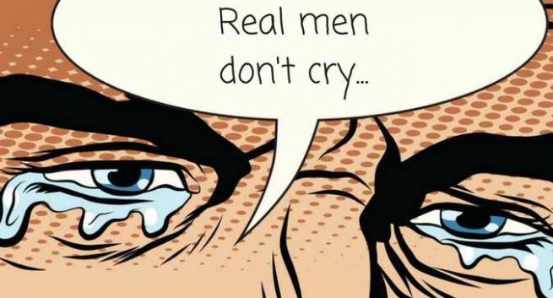
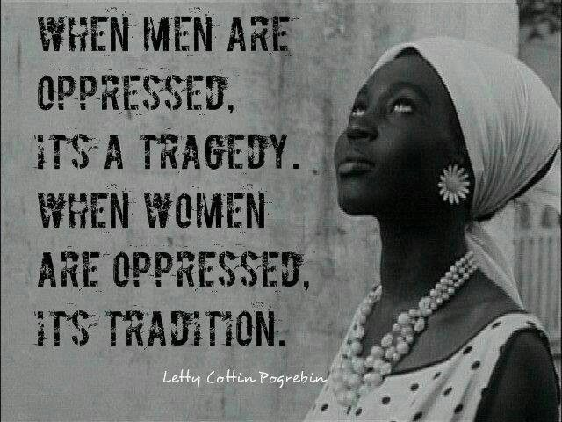

- “I'm very empathic to the construction of masculinity within our culture and how we build these identities up.” (Catherine Opie, Artist, 1961)
Incorporate this statement, or the ideas it contains, in a form of your choice.

CRITERIA AND CATEGORIES | Marks
Use of language – the response: | /10
Makes creative use of sophisticated, informed language to produce a meaningful text | 2
Makes thought-provoking use of informed language | 2
Makes competent use of language | 2
Makes unvaried and clichéd use of language | 2
Uses very literal, simplistic language only | 2
Use of narrative perspective – the response: | /10
Uses narrative perspective with imagination and skill | 2
Uses narrative perspective convincingly | 2
Uses narrative perspective effectively | 2
Uses some narrative perspective | 2
Uses an narrative perspective that is inconsistent | 2
Expression – the response is created: | /10
In a coherent and sophisticated style | 2
In a coherent and sustained style | 2
In a purposeful and/or methodical style | 2
Clearly but not always coherently | 2
In a disjoined style, characterized by unclear expression | 2
Total | /30
Mark converted to a percentage out of 5% for this assessment | 5%

